# **Deliverable 4: Wireframes & Feature Plan**

**CSC425 Fall 2025** **Student Name:** Mark Sharovarov  
 **Date Submitted:** *September 21, 2025* **GitHub REPO URL:** *https://github.com/MUS1C17/CSC425Team3* **Branch Name:** *MarkSharovarov-Delivarable4*

## **1) Low-Fidelity Wireframes (Mobile-First)**

Insert the images below into the corresponding spots in the template:

* **Login Screen**   
  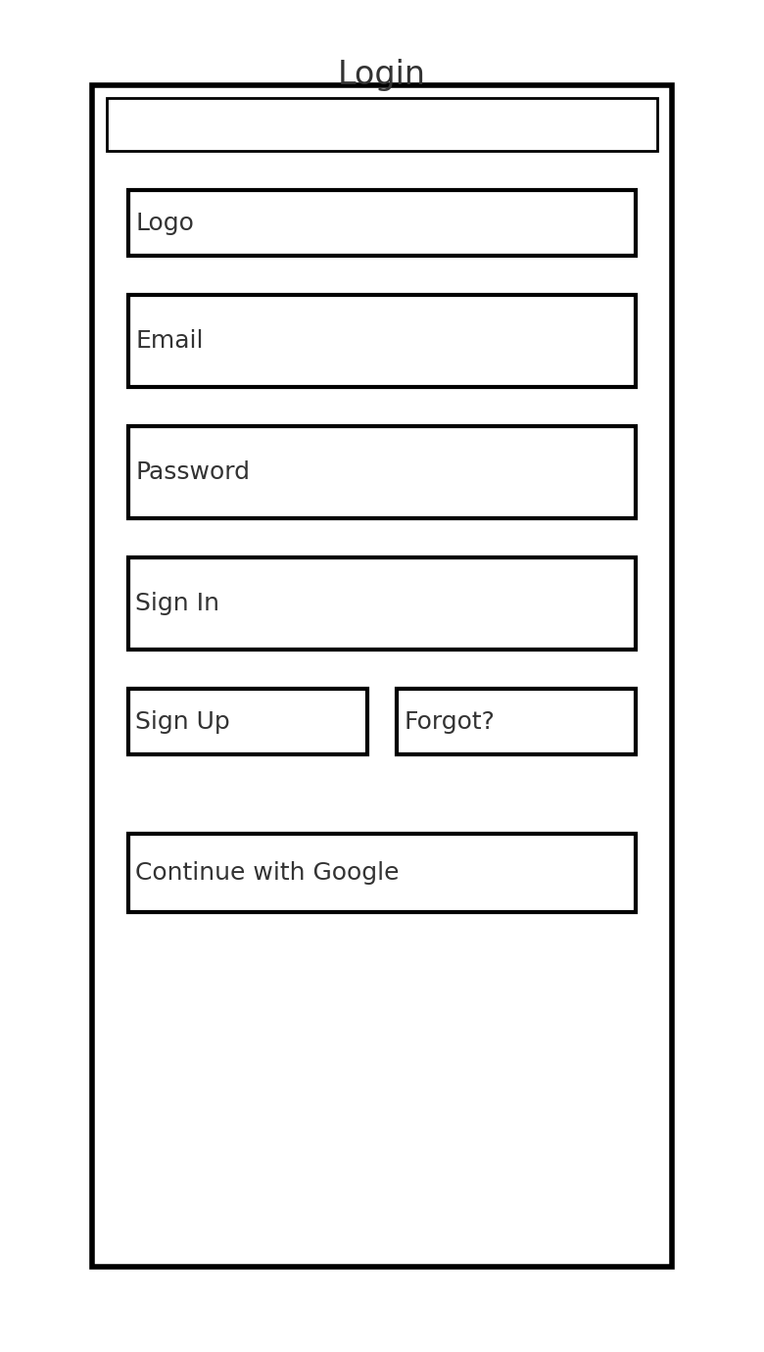
* **Dashboard Screen**

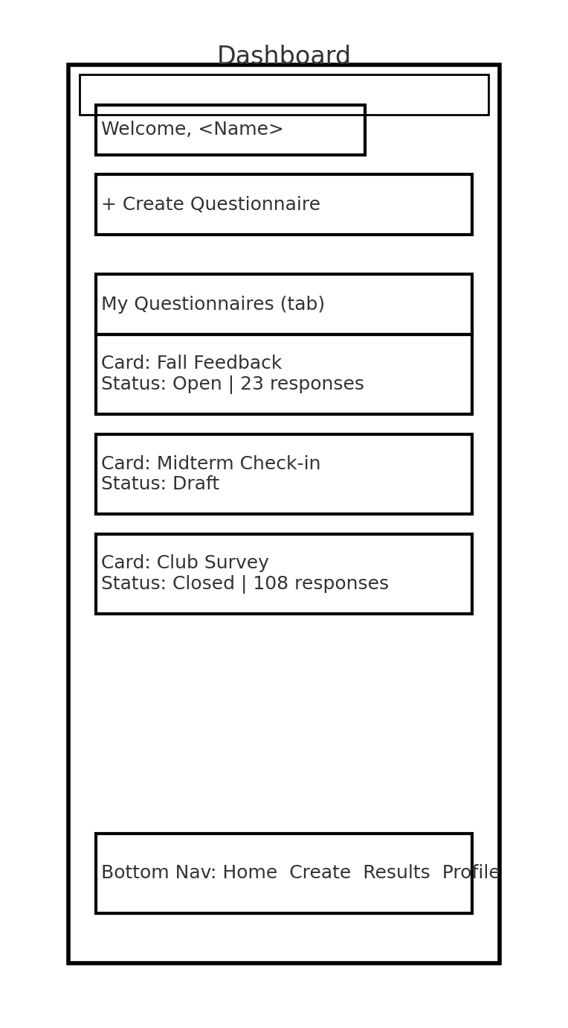

* **Create Questionnaire Screen**  
  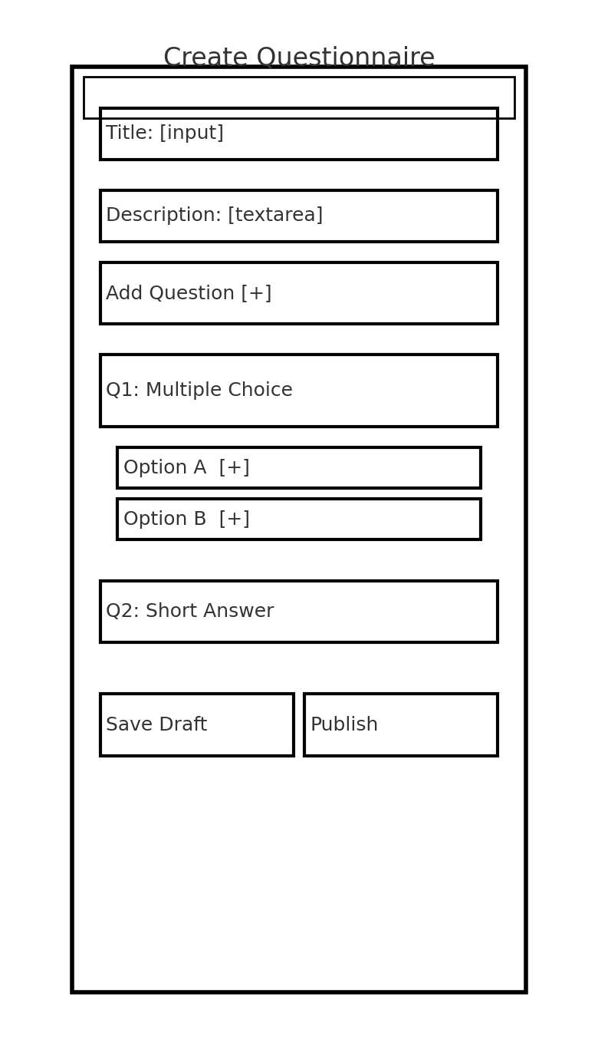
* **Take Questionnaire (Respondent) Screen**  
  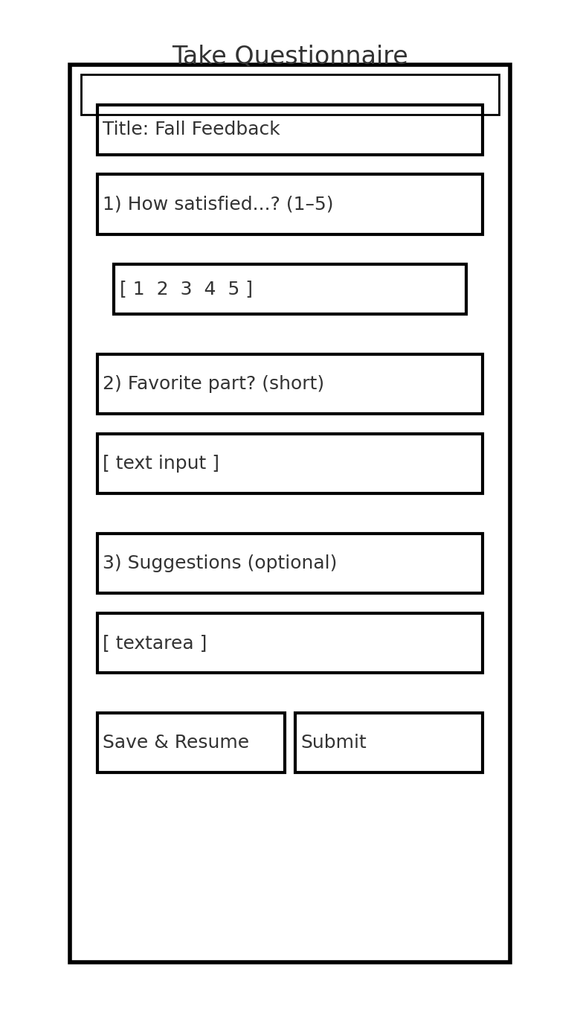
* **Results/Analytics Screen**  
  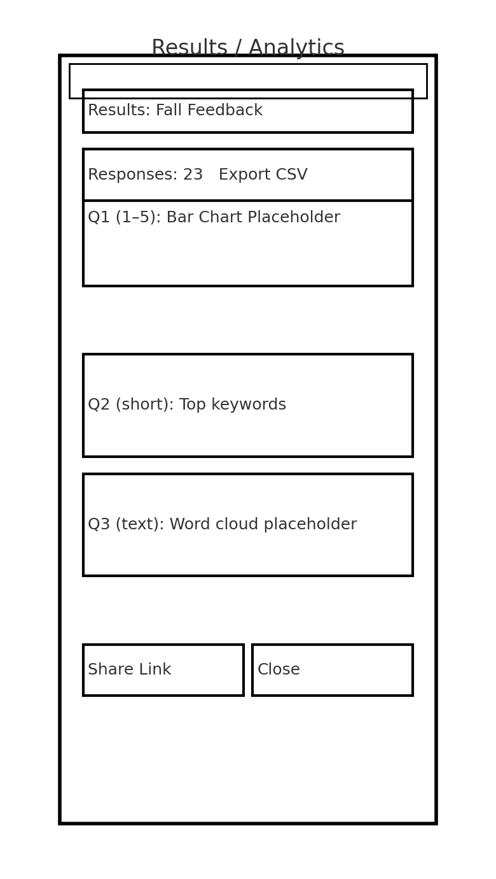

These are intentionally simple, black-line, mobile-first sketches that show structure (headers, key buttons, inputs, bottom-nav) without styling.

## **2) Functional Requirements**

* **Authentication**
  + Sign up, login, logout
  + Password reset and optional social login (Google)
  + Session management; protected routes (Dashboard, Create, Results)
* **Questionnaire Management (Creators)**
  + Create, read, update, delete questionnaires
  + Add, edit, reorder, delete questions (MCQ, Likert 1–5, short/long text, optional/required)
  + Draft vs Published states; Save as draft
  + Share via public URL/QR; optional access code
* **Response Collection (Respondents)**
  + Submit answers on mobile
  + Save & resume (link-based token)
  + Client-side validation and helpful error messages
* **Results & Analytics**
  + View response counts, completion rate
  + Auto charts for MCQ/Likert; keyword summary for short text
  + Export CSV (responses + metadata)
* **Navigation**
  + Mobile-first bottom navigation (Home/Dashboard, Create, Results, Profile)
  + Deep-linking from share URL to active questionnaire
* **Data & Storage**
  + Backend persistence (e.g., Supabase/Postgres)
  + Schema for Users, Questionnaires, Questions, Options, Responses, Answers
  + Soft-delete for safety; timestamps for auditing
* **Security & Access**
  + RLS/ACL so creators can only manage their own content
  + Basic rate-limiting on submissions
  + CAPTCHA or lightweight bot-protection on public forms
* **Quality & UX**
  + Input validation (required, min/max choices, text length)
  + Empty states, loading states, toasts
  + Error boundaries & graceful failure
* **Non-Functional**
  + Performance: load questionnaires < 2s on average campus Wi-Fi
  + Accessibility: semantic HTML, labels, keyboard navigation, color-contrast
  + Testing: unit tests for core logic; basic e2e for create→publish→respond→export

## **3) User Stories**

1. **As a creator**, I want to log in securely, so that I can access and manage my questionnaires.
2. **As a creator**, I want to add multiple types of questions (MCQ, Likert, short text), so that I can gather the right kind of feedback from participants.
3. **As a creator**, I want to publish a questionnaire and share a link/QR code, so that respondents can easily fill it out on their phones.
4. **As a respondent**, I want to save my progress and return later, so that I can complete longer questionnaires without losing my work.
5. **As a creator**, I want to view simple analytics and export a CSV, so that I can summarize results and include them in my report.

*(Optional extra)* 6. **As a creator**, I want to protect a questionnaire with an access code, so that only my intended audience can respond.

## **4) User Journey Flow**

**Option A (Diagram):** Insert this image into the template – Download Flow Diagram

**Option B (Written Description):**

1. User opens the app → sees **Login** (or **Sign Up**).
2. On successful auth → redirected to **Dashboard** with a list of questionnaires and a **Create** CTA.
3. User taps **Create Questionnaire** → fills **Title/Description**, adds questions, saves draft, then **Publishes**.
4. App generates a **Share Link/QR** → user distributes to respondents.
5. Respondent opens link on mobile → completes questions with validation → **Submit** (or **Save & Resume**).
6. Creator returns to **Results** → views charts and keyword summaries → **Export CSV** if needed.
7. User **Logs out**; session ends.

## **5) Document Layout Professional**

* This planning package is organized to be developer-ready: clear, scoped features; mobile-first wireframes; concrete data-flow; and user stories that map directly to tasks.